SABATIER COLLECTION
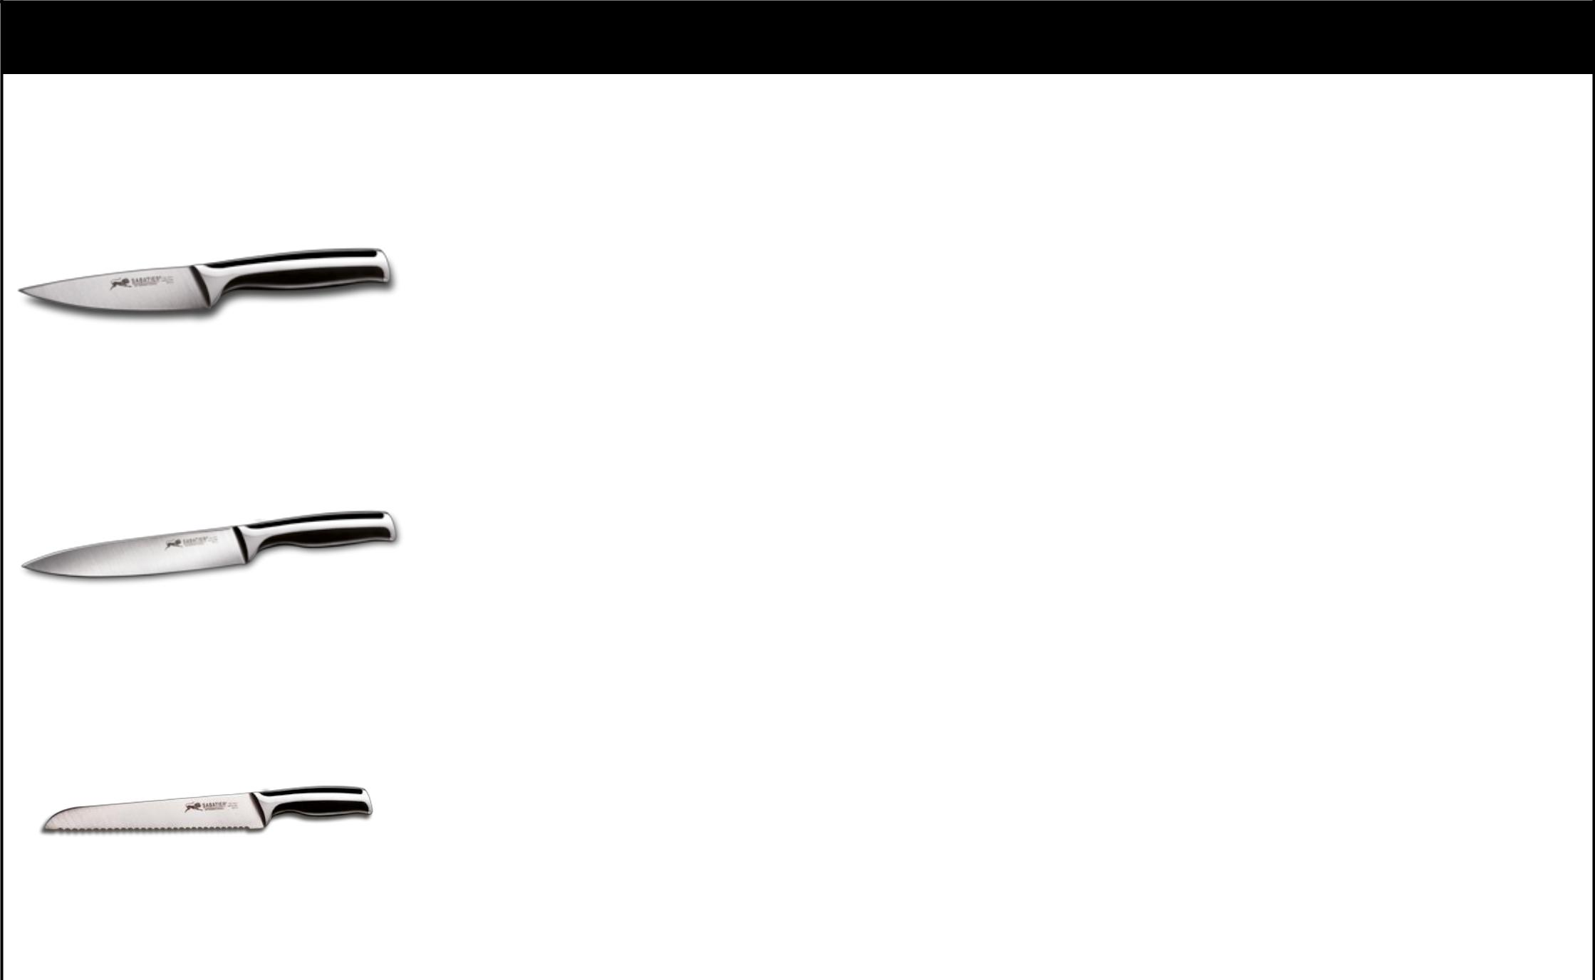
SABATIER COLLECTION

 | PHOTOS |  |  | QTY BY |  | QTY |  | TOTAL | QTY of
 | PHOTOS | ITEMS | DESCRIPTION | MASTER | SIZE | QTY | RETAIL | TOTAL | QTY of | REF
 |  |  |  |  |  |  |  |  | BOXES | REF
 |  |  |  | BOXE
 |  |  | BLADE 4CR13, RAW
 |  |  | MATERIAL 2 MM SATIN
 |  |  | FINISHED, TAPER
 |  |  | GRINDING. HANDLE: ABS
 |  | PARING | WITH S.S. 18/0 BOLSTER, | 48 | 9 CM | 87.162 | 14,90 € | 1.298.713,80 € | 1.816 | COL00001
 |  | KNIFE | MIRROR FINISHED.
 |  |  | BLACK ETCHING
 |  |  | MARKING ON THE KNITE:
 |  |  | SABATIER 1 LION + HIGH
 |  |  | CARBON STEEL X40CR13.
 |  |  | BLADE 4CR13, RAW
 |  |  | MATERIAL 2 MM SATIN
 |  |  | FINISHED, TAPER
 |  |  | GRINDING. HANDLE: ABS
 |  | UTILITY | WITH S.S. 18/0 BOLSTER, | 48 | 13 CM | 17.082 | 19,00 € | 324.558,00 € | 356 | COL00003
 |  | KNIVE | MIRROR FINISHED.
 |  |  | BLACK ETCHING
 |  |  | MARKING ON THE KNITE:
 |  |  | SABATIER 1 LION + HIGH
 |  |  | CARBON STEEL X40CR13.
 |  |  | BLADE 4CR13, RAW
 |  |  | MATERIAL 2,5 MM SATIN
 |  |  | FINISHED, TAPER
 |  |  | GRINDING. HANDLE: ABS
 |  | BREAD | WITH S.S. 18/0 BOLSTER, | 24 | 20 CM | 10.005 | 30,00 € | 300.150,00 € | 208 | COL00005
 |  | KNIFE | MIRROR FINISHED.
 |  |  | BLACK ETCHING
 |  |  | MARKING ON THE KNITE:
 |  |  | SABATIER 1 LION + HIGH
 |  |  | CARBON STEEL X40CR13.

SABATIER COLLECTION
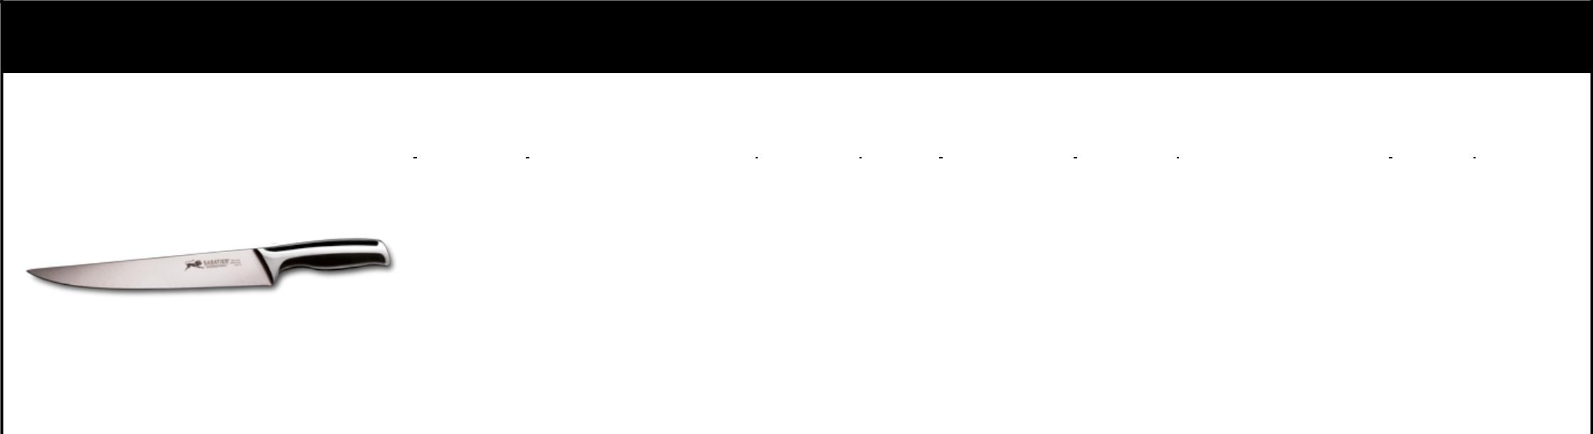
SABATIER COLLECTION

 | PHOTOS |  |  | QTY BY |  | QTY |  | TOTAL | QTY of
 | PHOTOS | ITEMS | DESCRIPTION | MASTER | SIZE | QTY | RETAIL | TOTAL | QTY of | REF
 |  |  |  |  |  |  |  |  | BOXES | REF
 |  |  |  | BOXE
 |  |  | BLADE 4CR13, RAW
 |  |  | MATERIAL 2,5 MM SATIN
 |  |  | FINISHED, TAPER
 |  |  | GRINDING. HANDLE: ABS
 |  | CARVING | WITH S.S. 18/0 BOLSTER, | 48 | 20 CM | 71.352 | 30,00 € | 2.140.560,00 € | 1.487 | COL00006
 |  | KNIFE | MIRROR FINISHED.
 |  |  | BLACK ETCHING
 |  |  | MARKING ON THE KNITE:
 |  |  | SABATIER 1 LION + HIGH
 |  |  | CARBON STEEL X40CR13.
 |  |  | BLADE 4CR13, RAW
 |  |  | MATERIAL 2 MM SATIN
 |  |  | FINISHED, TAPER
 |  | SET - 2 | GRINDING. HANDLE: ABS
 |  | SET - 2 | WITH S.S. 18/0 BOLSTER, | 32 |  | 50.336
 |  | STEAK | WITH S.S. 18/0 BOLSTER, | 32 | 12 CM | 50.336 | 33,00 € | 1.661.088,00 € | 1.049
 |  | STEAK | MIRROR FINISHED.
 |  | KNIVES | BLACK ETCHING
 |  |  | MARKING ON THE KNITE:
 |  |  | SABATIER 1 LION + HIGH
 |  |  | CARBON STEEL X40CR13.
 |  |  | WITH SCALLOP. BLADE
 |  |  | 4CR13, RAW MATERIAL 2,5
 |  |  | MM, SATIN FINISHED
 |  |  | TAPER GRINDING.
 |  | SANTOKU | HANDLE: ABS WITH S.S. | 48 |  | 31.279
 |  | SANTOKU | 18/0 BOLSTER, MIRROR | 48 | 18 CM | 31.279 | 33,00 € | 1.032.207,00 € | 652 | COL00008
 |  | KNIFE
 |  |  | FINISHED. BLACK
 |  |  | ETCHING MARKING ON
 |  |  | THE KNIFE: SABATIER 1
 |  |  | LION + HIGH CARBON
 |  |  | STEEL X40CR13
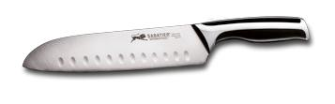
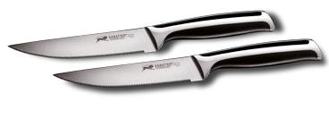
SABATIER COLLECTION
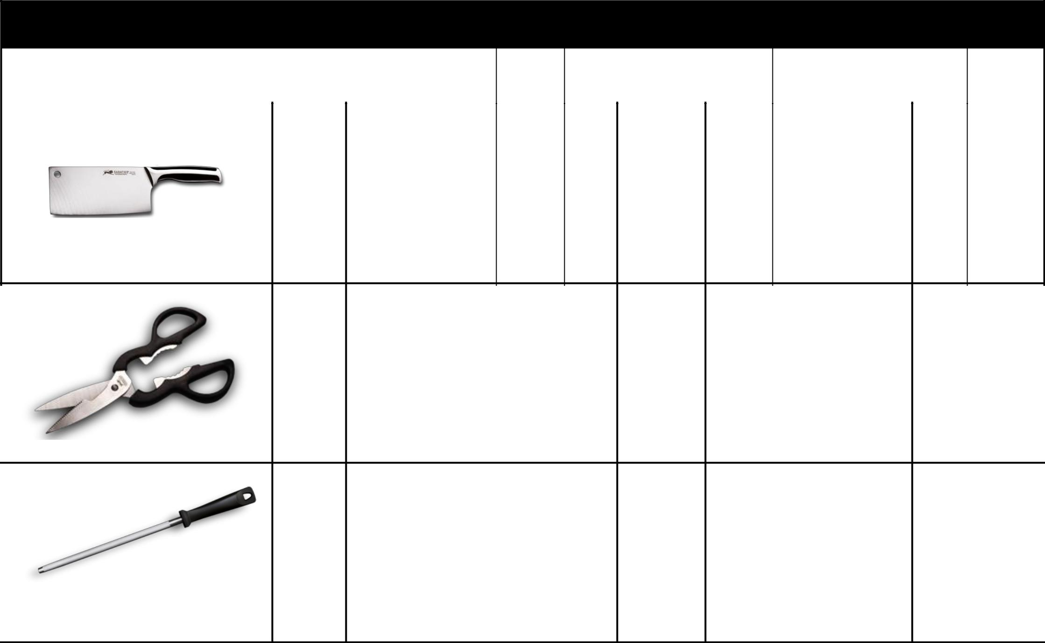
SABATIER COLLECTION

 | PHOTOS |  |  | QTY BY |  | QTY |  | TOTAL | QTY of
 | PHOTOS | ITEMS | DESCRIPTION | MASTER | SIZE | QTY | RETAIL | TOTAL | QTY of | REF
 |  |  |  |  |  |  |  |  | BOXES | REF
 |  |  |  | BOXE
 |  |  | BLADE: S.S. 18/0, SATIN
 |  |  | FINISHED. HANDLE: ABS
 |  |  | WITH S.S. 18/0 BOLSTER, | 32 |  | 5.247
 |  | CLEAVER | SATIN FINISHED. BLACK | 32 | 16,5 CM | 5.247 | 40,00 € | 209.880,00 € | 219 | COL00009
 |  |  | ETCHING MARKING ON
 |  |  | THE CLEAVER: SABATIER
 |  |  | 1 LION

BLADE 2CR13. HANDLE:
ABS. BLACK ETCHING | 32 | 4.704
SCISSORS MARKING ON THE | 32 | 4.704 | 10,00 € | 47.040,00 €147 | COL00010
SCISSORS: SABATIER 1
LION

SHARPENER | BLADE: IRON, CHROME | 32 | 25 CM | 144 | 20,00 € | 2.880,00 € | 24 | COL00036
SHARPENER | PLATED. HANDLE: PP

SABATIER COLLECTION
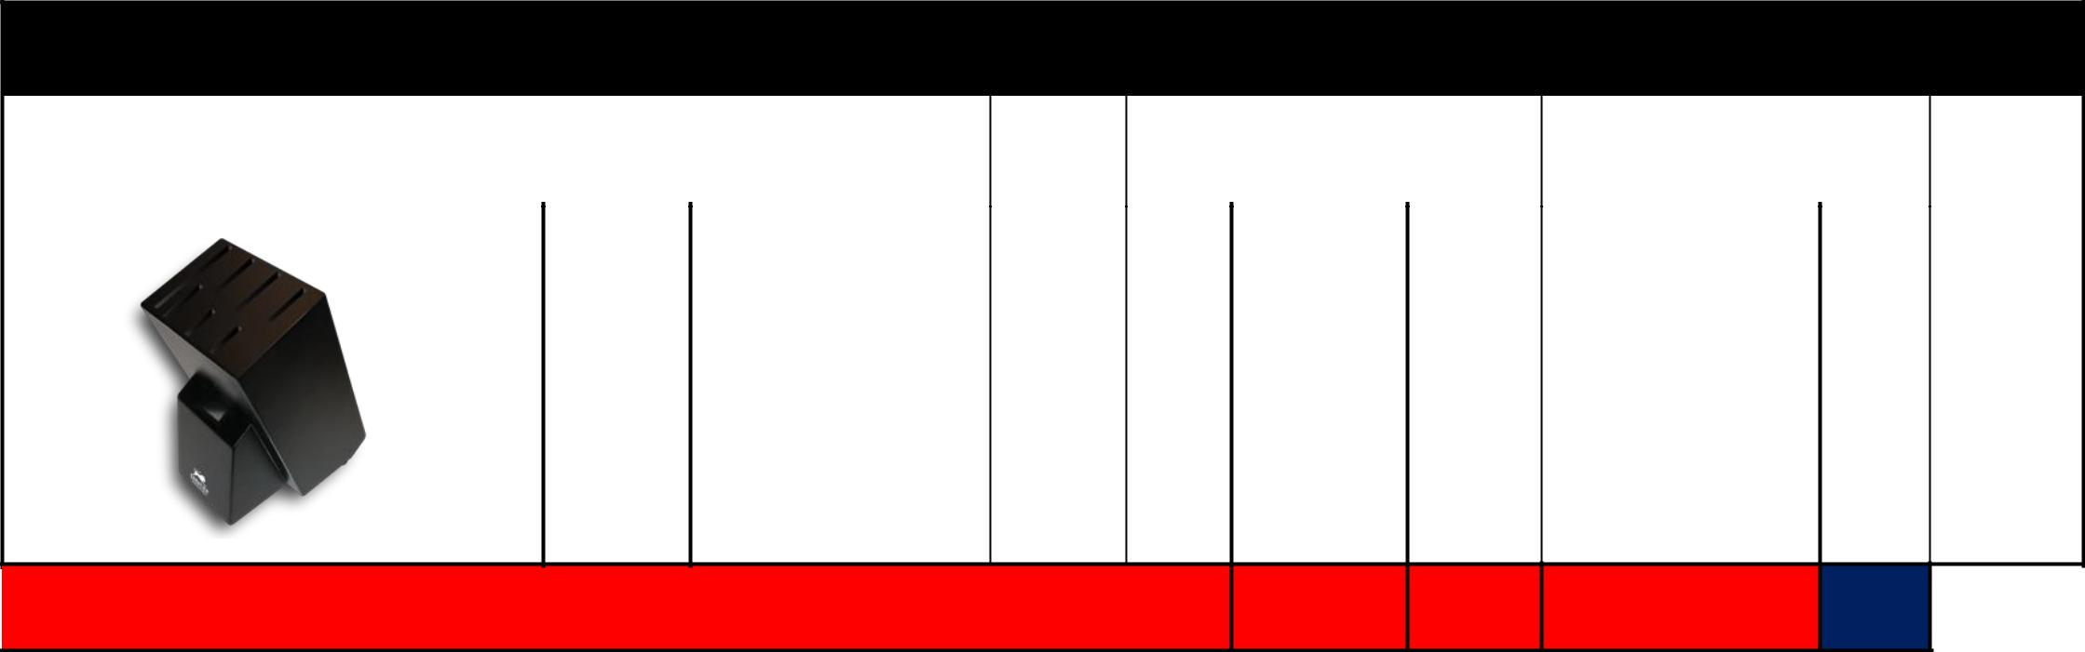
SABATIER COLLECTION

 | PHOTOS |  |  | QTY BY | QTY |  | TOTAL | QTY of
 | PHOTOS | ITEMS | DESCRIPTION | MASTERSIZE | QTY | RETAIL | TOTAL | QTY of | REF
 |  |  |  |  |  |  |  | BOXES | REF
 |  |  |  | BOXE

MATERIAL: RUBBER
WOOD + PINE WOOD | 4 | 18 X 12.6 | 18.196
BLOCKINSIDE. WHITE SILK | 4 | X 20.5 | 18.196 | 50,00 € | 909.800,00 € 4.549 | COL00012
MARKING ON THE BLOCK: |  | CM
SABATIER 1 LION

TOTAL SABATIER

295.507 26,82 € 7.926.876,80 € 10.506

